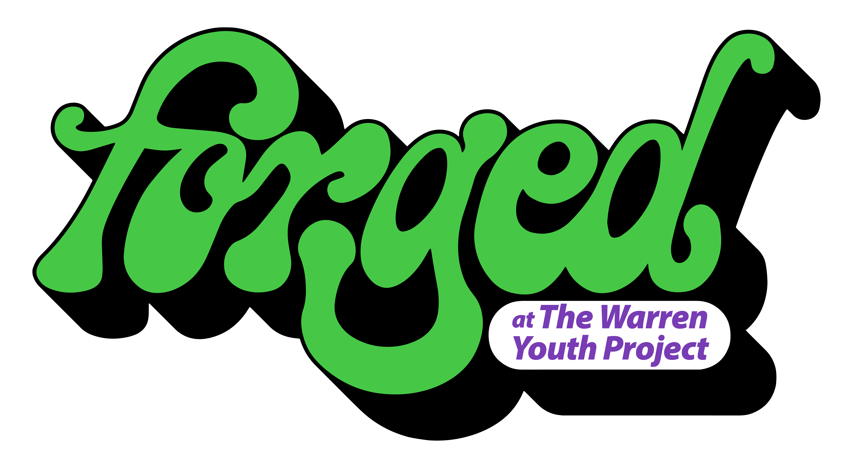

‘Leg Up’ Fund
Application Form

Thank you for your interest in applying for The Warren’s Leg Up fund.
Please make sure before completing this form that you are eligible for this fund: You are aged between 16-25 and live in a place with a HU postcode.

We are asking for young people to pitch to us what they need to get a leg up in their creative practise. This could be a piece of equipment, an instrument, covering costs to diversify skills or purchasing materials to start a small creative business. Whatever is being requested must be linked to a creative skill and cost anything between £100-£500.
Please note: this is not a fund where you are awarded the money you request. If you are successful, Forged will award you with the items you request in this application.

Name:
Age:
First part of your postcode:

What is your creative hobby/ interest/ profession? (100 words)

Examples of your work:
This could be a link to a website/ examples of music or photos of your work.

What current barriers do you face that stop you from following your creative path? (250 words)

What is it you need for a Leg Up?(250 words)

Please include links to any equipment/ software/ materials you are requesting and make sure it does not have a total value of over £500.

What will this fund enable you to do?(250 words)

If you were awarded this fund, what difference would it make to:

A- Your creative practise/ development? (250 words)

B- You personal well-being?(250 words)

Any further info you wish to include?(250 words)

For this fund, we accept written applications as well as a voice note or video application These should be no longer than 5 minutes. If you choose to send a voice note/video please ensure you answer every question and send links and examples along with your application.

What happens next?
We will make decisions on who this fund is awarded to in September 2026.You will be informed whether you have been successful or not.

If you are successful, we will purchase the items in your application. In March 2027, we will require a 6 month catch up, to see what difference this fund has made to your creativity.
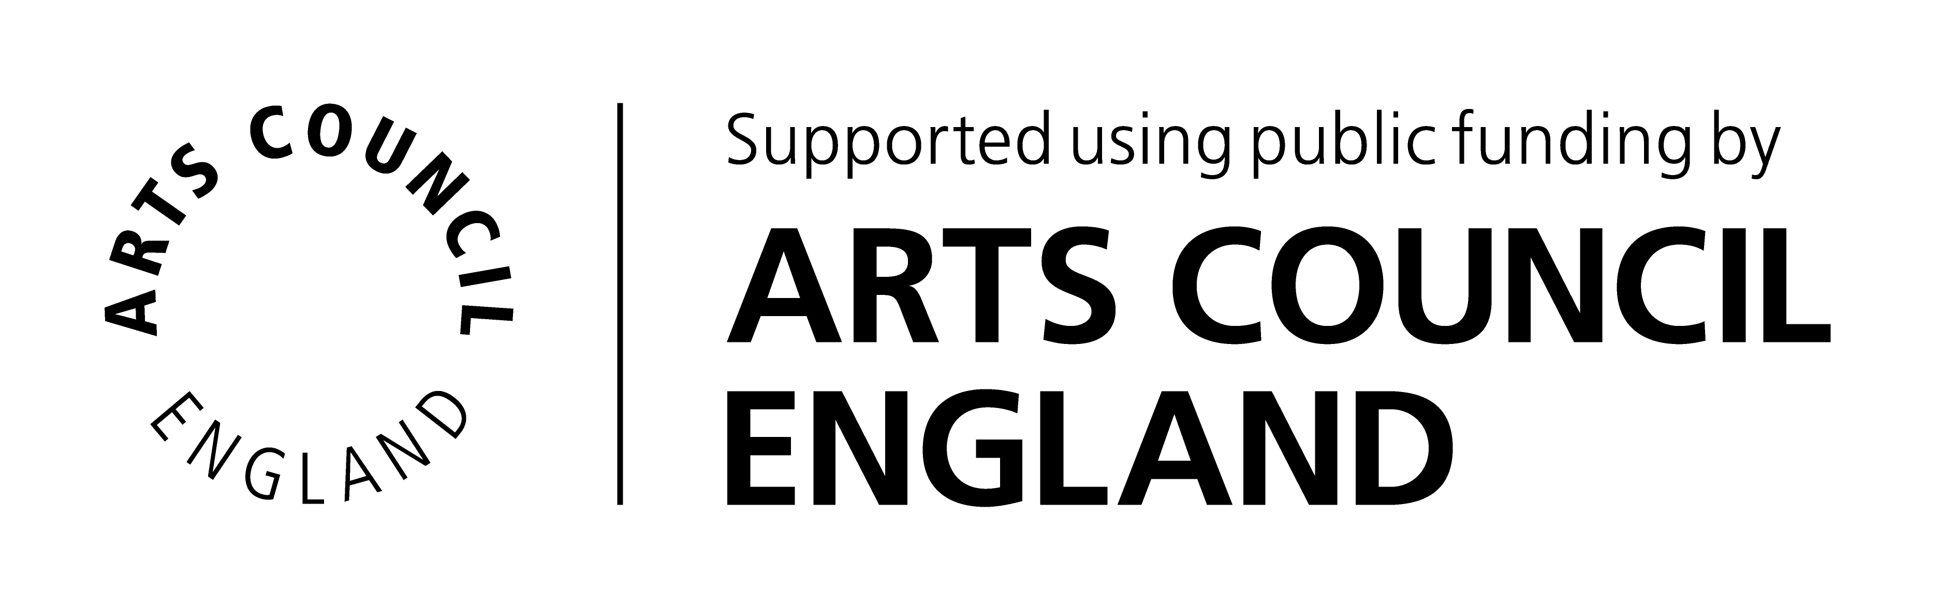

This fund is made possible by Arts Council England Funding.

